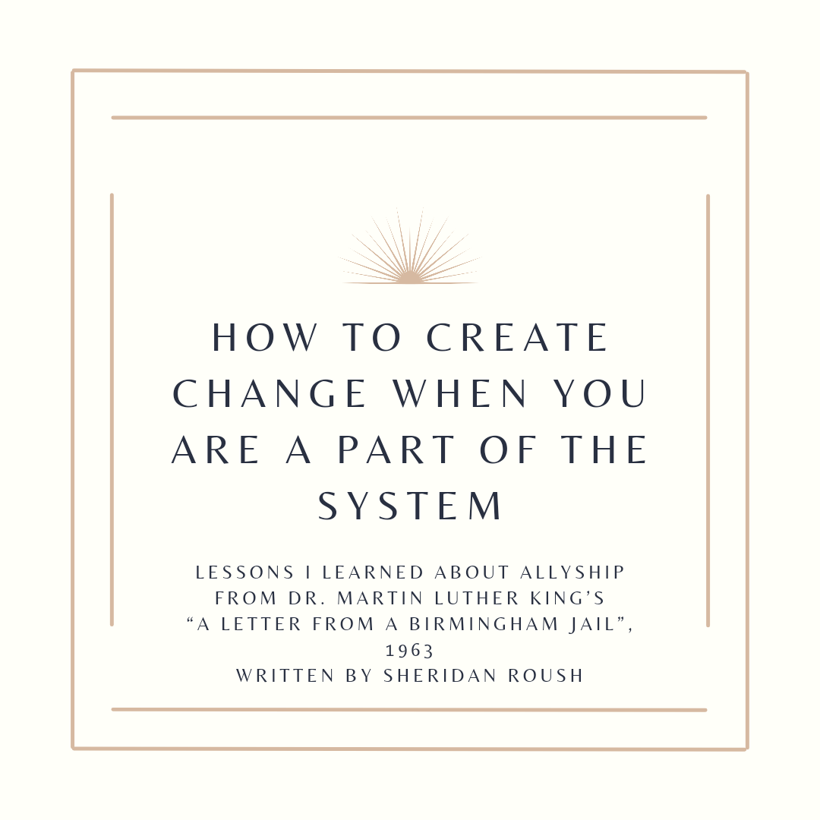
I am not sure when I realized the “White Man” that civil rights leaders referred to, meant “White People” collectively and “White supremacy”. I became aware that I, a White woman, was included in this group. I was embarrassingly late to this realization. It was even later when I became aware that I could be a part of perpetuating the “systems of oppression” so often spoken and written about. The thought of peacefully dismantling systemic racism and White dominance, was, and still is, a daunting and overwhelming ideal for me to grasp. How can I be a part of dismantling something that I was, and maybe still am, a part of?

In my late teens and early twenties, I worked as a mental health service provider and taught life skills to adults. I enrolled in a psychology program at a university and started learning about the developmental needs of children. I learned that it is much easier to help cull unjust biases and behaviors early in the life of a child. I believe that the most direct way that I can help dismantle oppressive systems and facilitate positive change in our racialized society is to be an early childhood educator. Our classroom’s peace curriculum is a good start, but expanding upon its core lessons of grace, courtesy, and developing relationships is an effective approach, especially for children. Our peace education should be one that models how to interact with others and avoid unnecessary bias, aggressions, microaggressions, and racism. Maria Montessori taught us that unless we demonstrate this to children via adult actions, it will be impossible to create a peaceful society.

I was drawn to the Montessori approach because the philosophy and pedagogy demands that we teach the whole child, and not just focus on academic achievement. As White educators, we have an important charge to prepare our environments in a way that cultivates a sense of belonging for all children. This means recognizing and understanding the intersection between peace, diversity, equity, justice, and inclusion.

As a White woman I am practicing how to create space for the experiences of Black, Indigenous, and People of Color (BIPOC) and not center my own. This is not easy to master. Throughout this text, I highlight quotes from Martin Luther King’s “A Letter from a Birmingham Jail that he wrote in 1963 to frame my understanding of White allyship today. (King, 1963) Dr. King wrote, “There is a type of constructive nonviolent tension that is necessary for growth.” The cognitive dissonance of being White and benefitting (consciously or not) from oppressive systems that disadvantage People of the Global Majority, while simultaneously working to end these systems, is the kind of tension that forces growth.

In this same letter Dr. King also speaks of the White moderate, “who lives by a mythical concept of time.” There is no more time to wait, what is needed at this time, in the Montessori Movement, are White allies and disruptors. “We need not follow the do-nothingism of the complacent. Freedom dies when enough people do nothing.” "Ally" is not an identity but rather an ongoing and lifelong process and commitment to action that involves a lot of work. Allies don’t have it all figured out, but they are committed to non-complacency. An ally acknowledges the limits of their knowledge about oppressed people’s experiences but doesn't use that as a reason not to think and/or act. A way to begin as an educator is to become an ally of your students and their families. We can learn about their experiences, lift up their culture, create trust and community within and outside of our classrooms. To be an ally within our school starts by creating community and being the model for our students.

We can act immediately. We don’t have to approach this work all at once. Interrogating our beliefs about race, oppression, and privilege is a great place to start. We as White people should have some courageous, open, and honest dialogue with BIPOC community members in and outside of our school communities to cultivate a deeper understanding of our White identity in relation to them. Dr. King wrote, “Too long has our beloved Southland been bogged down in the tragic attempt to live in monologue rather than dialogue.” While many of these conversations won't be easy, the more vulnerable conversations we have, the more we will grow to develop the necessary skills to identify, confront, and disrupt the impacts of Whiteness personally, collectively, and professionally.

Being an educator is how I spend most of my day, essentially most of my time spent on Earth. Why not spend it doing something truly meaningful? What can you do as an educator, administrator, or parent this month, and in months and years to come, to answer this call to action? We can no longer answer, “Wait until a ‘more convenient season.’" We can do so much as of now, so let's start today.

Citation

Martin Luther King, Jr. A “Letter from a Birmingham Jail”, 1963. BlackPast, B.
Retrieved from: https://www.blackpast.org/african-american-history/1963-martin-luther-king-jr-letter-birmingham-jail/ February 1, 2023

References

Allyship and Anti-Oppression: A Resource Guide. Research Guides at Tri-College Libraries.
Retrieved from: https://guides.tricolib.brynmawr.edu/c.php?g=285382&p=1900870
February 13, 2023

Sherriff, Gina. "Letter from Birmingham Jail Letter from Birmingham Jail." Summary and Analysis. LitCharts. LitCharts LLC, 6 Dec 2018.
Retrieved from: https://www.litcharts.com/lit/letter-from-birmingham-jail/summary-and-analysis February 13, 2023

Talking About Race: Whiteness. National Museum of African American History and Culture.
Retrieved from: https://nmaahc.si.edu/learn/talking-about-race/topics/whiteness
February 13, 2023

Top graphic created using a template from Canva

About the Author

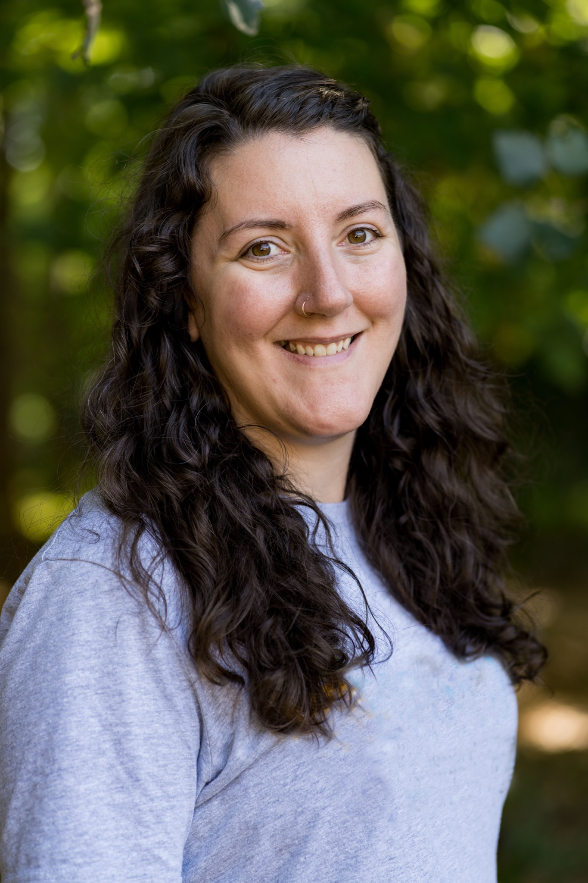

Sheridan Roush serves young students as a primary-level teacher at the Montessori School of Northern Virginia, where she lives with her husband and two young children. She earned her Early Childhood AMS certificate while teaching in a Montessori classroom in Beijing, China. As a teacher in an early childhood Montessori classroom for the past eleven years, she has seen the importance of creating an environment of fair and equitable practices for young learners and their families. Hailing from West Virginia where she earned her bachelor’s degree in psychology, Sheridan is a licensed special education teacher and is currently in the Master of Special Education program at George Mason University.

